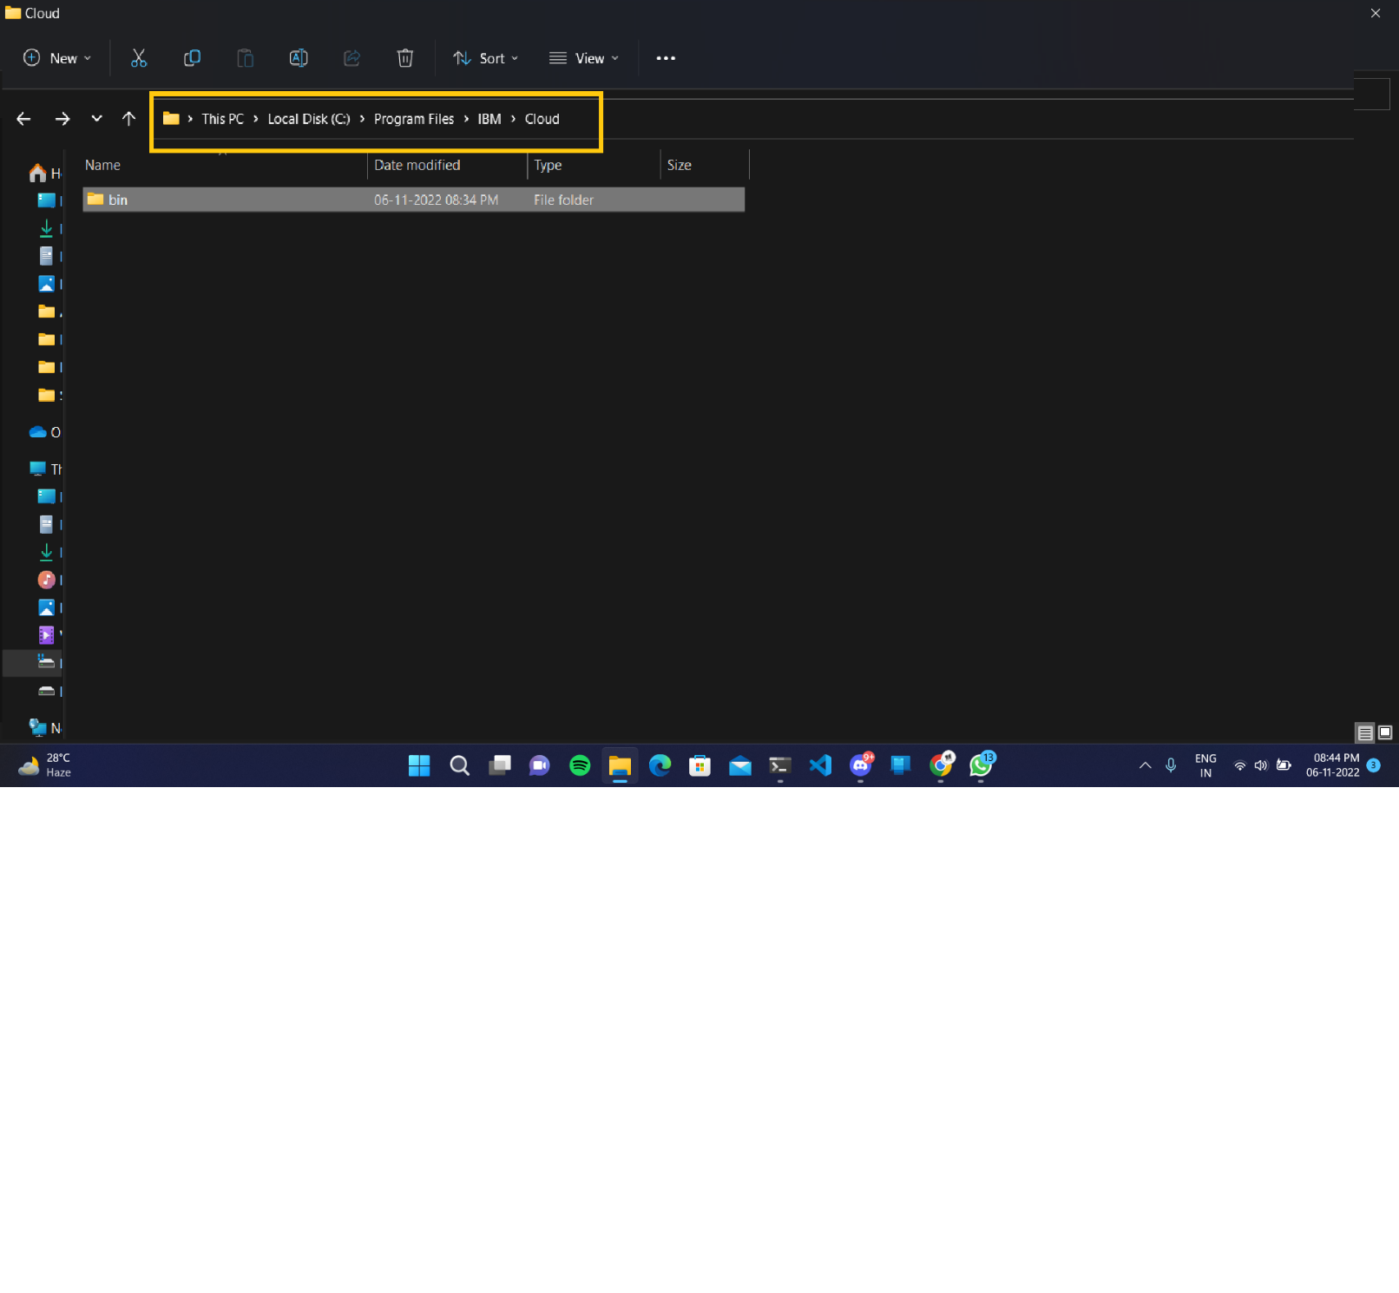**IBM CLOUD CLI INSTALLATION**